1. Once the file is downloaded from remote system to the staging area

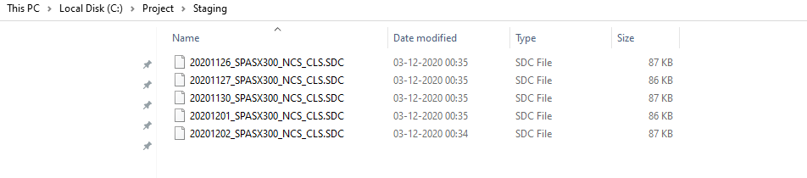

1. Once all the files are loaded into the relational db and the target table

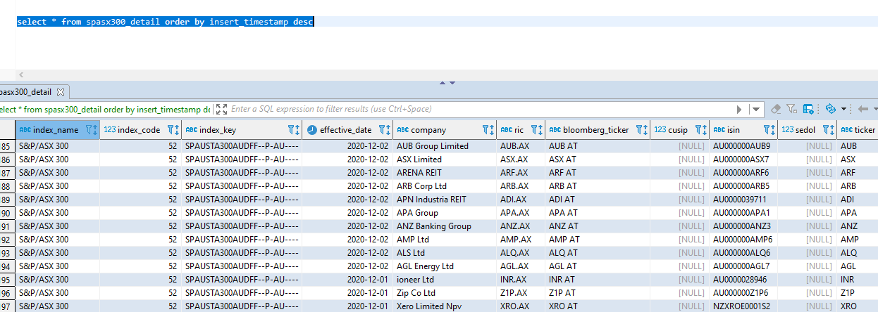

1. Finally, the files are moved to the archive folder

